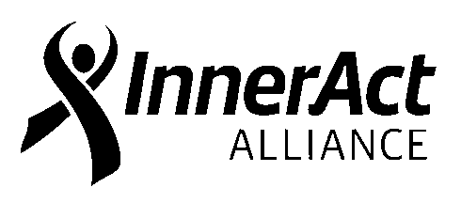
RED RIBBON CAMPAIGN ORDER FORM

The following Red Ribbon items are available for purchase through InnerAct Alliance. Please call (863) 802-0777 or email the order to angie.ellison@inneractalliance.org. Please allow at least 2 weeks to fill your order. Red Ribbon Week is October 23-31!

ITEM # ORDERED TOTAL DONATION

2 x 5 inch Self-Adhesive Red Lapel Ribbon
@ $.10 donation

Check here if you prefer to receive ribbon only without prevention information sheet attached (with pin)

“Red Ribbon” Pencil @ $.20 donation

Special Business Promotion Package @ $25.00 donation (includes 200 self-adhesive lapel ribbons
and 200 information sheets in a small basket, along with a Red Ribbon Campaign support sign that we will deliver to you.)
GRAND TOTAL:

Organization: __

Address: Contact Name:

Phone #: E-Mail Address: Courier Route #: __ Check #: Amount Enclosed: __ __ P.O.#: _

Special business promotion packages will be delivered to businesses. All other items will be available for pick up at the InnerAct Alliance office at 621 South Florida Avenue, Lakeland, between the hours of 8:30 AM and 4:30 PM. (or by courier for schools) Please make Checks Payable to: InnerAct Alliance, 621 South Florida Avenue, Lakeland, FL 33801. DONATIONS ARE DUE AT THE TIME ORDERS ARE PICKED UP.
Please call (863) 802-0777 before picking up your order. Thanks for your support!

6/26/18

Order Filled by: Date Filled:

